**Program Code –**

ACCEPT v_roll NUMBER PROMPT 'Enter Roll No: '

ACCEPT v_book CHAR PROMPT 'Enter Book Name: '

SET SERVEROUTPUT ON;

DECLARE

v_rollno NUMBER := &v_roll;

v_bookname VARCHAR2(50) := '&v_book';

v_dateissue DATE;

v_days NUMBER;

v_fine NUMBER := 0;

BEGIN

-- Fetch Date of Issue

SELECT DateofIssue INTO v_dateissue

FROM Borrower

WHERE Roll_no = v_rollno AND NameofBook = v_bookname AND Status = 'I';

-- Days kept

v_days := TRUNC(SYSDATE - v_dateissue);

-- Fine Calculation

IF v_days <= 15 THEN

v_fine := 0;

ELSIF v_days > 15 AND v_days <= 30 THEN

v_fine := (v_days - 15) * 5;

ELSE

v_fine := (15 * 5) + ((v_days - 30) * 50);

END IF;

-- Update status

UPDATE Borrower

SET Status = 'R'

WHERE Roll_no = v_rollno AND NameofBook = v_bookname;

-- Insert fine if any

IF v_fine > 0 THEN

INSERT INTO Fine (Roll_no, FineDate, Amt)

VALUES (v_rollno, SYSDATE, v_fine);

END IF;

COMMIT;

DBMS_OUTPUT.PUT_LINE('Book Returned Successfully.');

DBMS_OUTPUT.PUT_LINE('Days Kept: ' || v_days);

DBMS_OUTPUT.PUT_LINE('Fine Amount: ' || v_fine);

EXCEPTION

WHEN NO_DATA_FOUND THEN

DBMS_OUTPUT.PUT_LINE('No record found for given Roll_no and Book.');

WHEN OTHERS THEN

DBMS_OUTPUT.PUT_LINE('Error: ' || SQLERRM);

END;

/

**Output –**

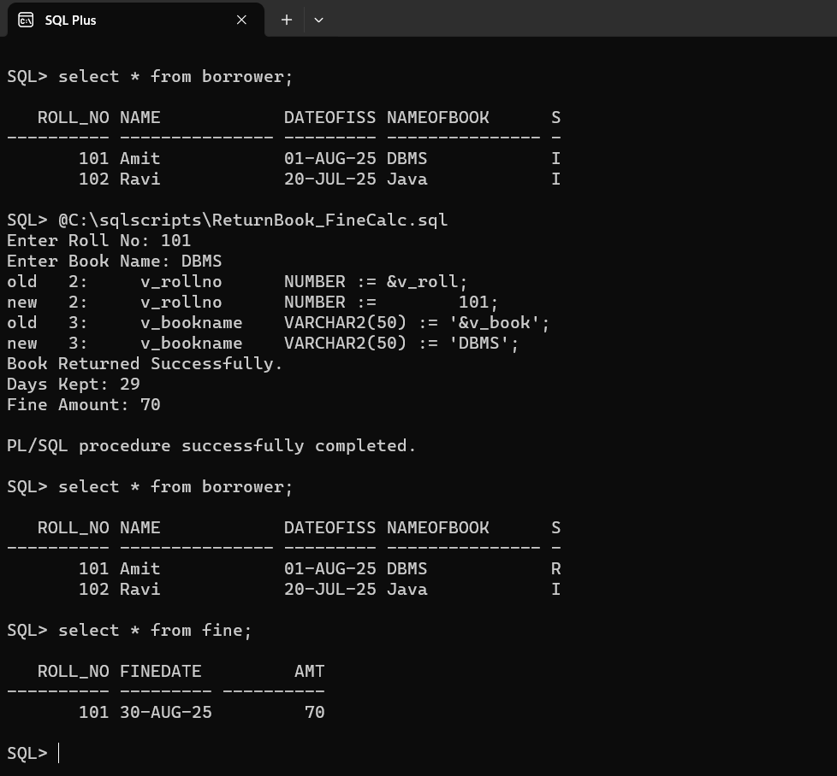

**Program Code -**

ACCEPT user_option NUMBER PROMPT 'Enter 1 for FOR loop or 2 for WHILE loop: '

SET SERVEROUTPUT ON;

DECLARE

v_option NUMBER := &user_option;

v_radius NUMBER;

v_area NUMBER;

BEGIN

CASE v_option

WHEN 1 THEN

DBMS_OUTPUT.PUT_LINE('Using FOR loop...');

FOR r IN 5..9 LOOP

v_area := 3.14159 * r * r;

INSERT INTO areas VALUES (r, v_area);

END LOOP;

WHEN 2 THEN

DBMS_OUTPUT.PUT_LINE('Using WHILE loop...');

v_radius := 5;

WHILE v_radius <= 9 LOOP

v_area := 3.14159 * v_radius * v_radius;

INSERT INTO areas VALUES (v_radius, v_area);

v_radius := v_radius + 1;

END LOOP;

ELSE

DBMS_OUTPUT.PUT_LINE('Invalid option! Enter 1 or 2.');

END CASE;

COMMIT;

DBMS_OUTPUT.PUT_LINE('Data inserted into AREAS table.');

END;

/

**Output -**

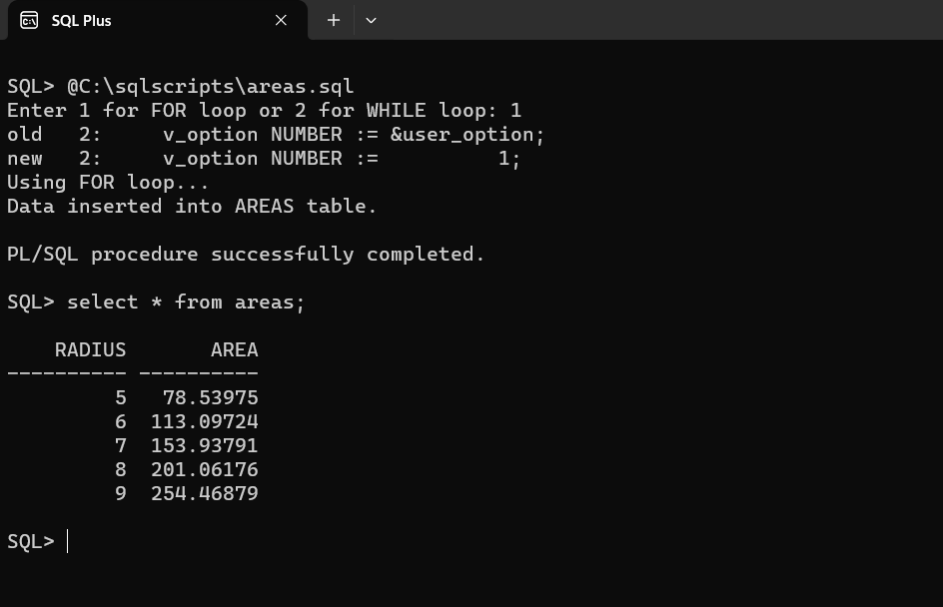

**Program Code -**

SET SERVEROUTPUT ON;

CREATE OR REPLACE FUNCTION fn_GetGrade(p_marks NUMBER)

RETURN VARCHAR2 IS

v_class VARCHAR2(30);

BEGIN

IF p_marks BETWEEN 990 AND 1500 THEN

v_class := 'Distinction';

ELSIF p_marks BETWEEN 900 AND 989 THEN

v_class := 'First Class';

ELSIF p_marks BETWEEN 825 AND 899 THEN

v_class := 'Higher Second Class';

ELSE

v_class := 'Not Categorized';

END IF;

RETURN v_class;

EXCEPTION

WHEN NO_DATA_FOUND THEN

RETURN 'No Data Found';

WHEN OTHERS THEN

RETURN 'Error Occurred';

END;

/

CREATE OR REPLACE PROCEDURE proc_Grade IS

BEGIN

DELETE FROM Result;

INSERT INTO Result (roll, name, class)

SELECT roll,

name,

fn_GetGrade(total_marks)

FROM Stud_Marks;

COMMIT;

EXCEPTION

WHEN NO_DATA_FOUND THEN

DBMS_OUTPUT.PUT_LINE('No Data Found in Stud_Marks');

WHEN OTHERS THEN

DBMS_OUTPUT.PUT_LINE('Error: ' || SQLERRM);

END;

/

BEGIN

proc_Grade;

DBMS_OUTPUT.PUT_LINE('Student Grades Inserted into Result table');

EXCEPTION

WHEN OTHERS THEN

DBMS_OUTPUT.PUT_LINE('Error in main block: ' || SQLERRM);

END;

/

**Output –**

